Link: [How to Communicate Waterproof Ultrasonic Sensor AJ-SR04M/JSN-SR04T with Arduino/ESP32 – Probots Blog](https://tutorials.probots.co.in/communicating-with-a-waterproof-ultrasonic-sensor-aj-sr04m-jsn-sr04t/)

As ultrasonic sensors started being used in cars as reverse parking sensors, manufactures started producing them in bulk which made them easily available in a wide variety of models at cheap prices. We at Probots ([www.probots.co.in](http://www.probots.co.in/)), sell a wide range of ultrasonic sensors which are easy and simple to interface with microcontrollers.

[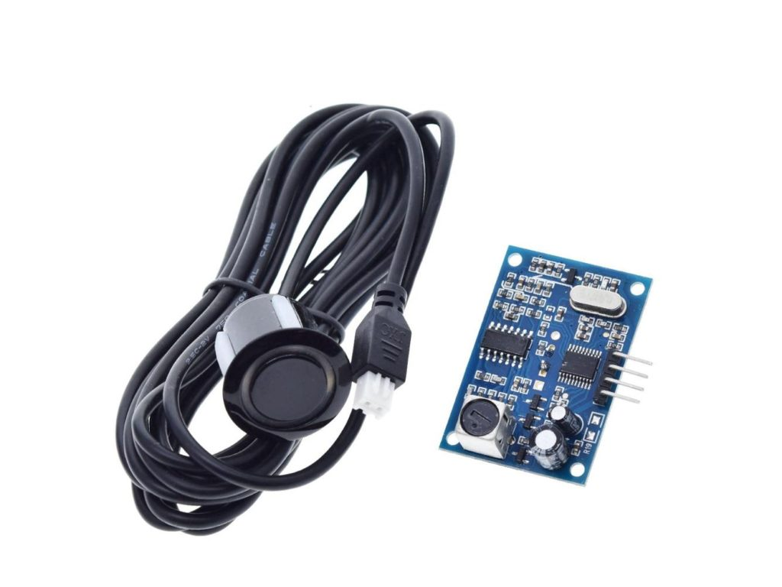](https://www.probots.co.in/waterproof-ultrasonic-distance-sensor-module-jsn-sr04t.html)Waterproof Ultrasonic Distance Sensor Module JSN-SR04T

The most versatile and accurate of them is the Waterproof Ultrasonic Sensor AJ-SR04M/JSN-SR04T V2.0. It can detect objects up to 4.5meters, has a very practically useful beam angle of 45 degrees, is accurate up to 0.5cm. Unlike other ultrasonic sensors HC-SR04, JSN-SR04T, and the JSN-SR04T V2, the AJ-SR04M offers a wide range of operating voltage 3-5V(which means it can work on both 5V and 3.3V microcontrollers), has a low power consumption of only 20uA during sleep(which means it can run on batteries for years!). The other sensors HCSR05 and JSN-SR04T have high operating voltage and current consumption( which makes the AJ-SR04M is the best choice for designing consumer products).

Make sure you buy only genuine sensors which come fully functionally tested. Many fakes, clones, and low-cost modules may not give you these options and you may be unable to get them working following this guide.

***Check out our website***[***www.probots.co***](http://www.probots.co.in/)***.in to find all the parts for your projects! We have 2000+ Electronic Modules, Sensors, and Components for all your electronics projects.***



You can purchase this signal generator here – [Buy Now](https://www.probots.co.in/waterproof-ultrasonic-distance-sensor-module-jsn-sr04t.html)

The sensor has multiple operating modes –

1. Traditional Trigger and Echo Mode
2. Low Power Traditional Trigger and Echo Mode
3. Automatic Serial Port Mode
4. PWM Output

There are many articles and YouTube videos showing that JSN-SR04T V2 and AJ-SR04M are not working and they recommend using SN-SR04T. But they didn’t put in an effort to get them working but just concluded that an older sensor JSN-SR04T with fewer features is better.

We recently delivered a custom electronics product using the AJ-SR04M and were able to get it working with no issues. The product has already reached the market and has been received with high satisfaction from both our customers and their users.

If you are trying to use this ultrasonic sensor in your product or project, then this article will help you get it working immediately. We sell the same sensor on our website – [Buy Now on www.probots.co.in](https://www.probots.co.in/waterproof-ultrasonic-distance-sensor-module-jsn-sr04t.html)

**Table of Contents**

* [Modes Selection:](https://tutorials.probots.co.in/communicating-with-a-waterproof-ultrasonic-sensor-aj-sr04m-jsn-sr04t/#modes-selection)
* [The AJ-SR04M has 5 working modes:](https://tutorials.probots.co.in/communicating-with-a-waterproof-ultrasonic-sensor-aj-sr04m-jsn-sr04t/#the-aj-sr04m-has-5-working-modes)

**Modes Selection:**

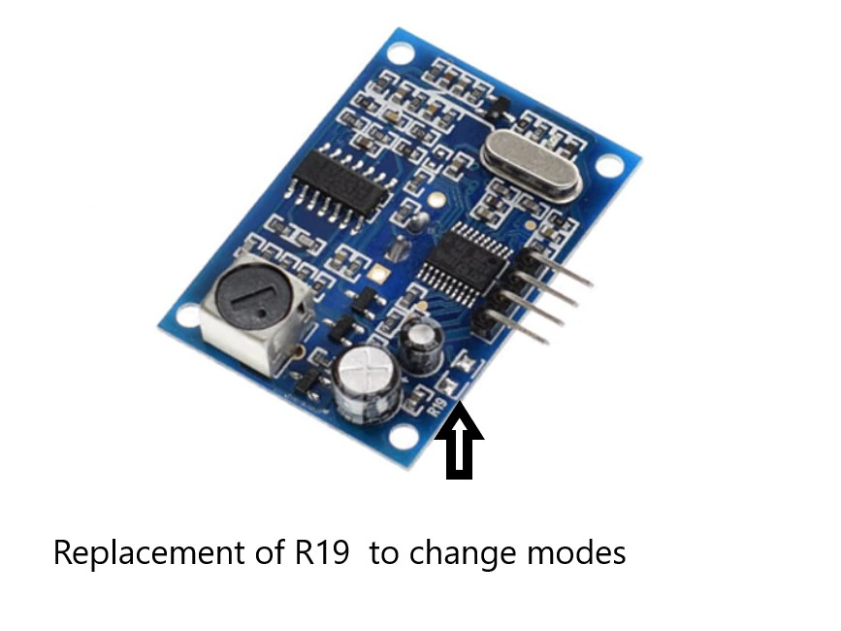An onboard resistor selects the mode of the module

**Specification:**

* Operating Voltage: DC 5V
* The Module is has an operating range of 20cm to 450cm.
* Total Current Draw:30mA
* Frequency: 40KHZ
* Resolution : about 0.5cm
* Beam Angle: less than 50 degrees
* Working Temperature:-10~70° C
* Storage temperature:-20~80° C

**Board Overview :**

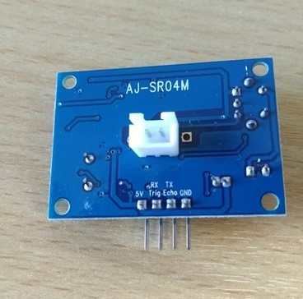Sensor Main Board

**The AJ-SR04M has 5 working modes:**

1. Traditional Trigger and Echo Mode (same as the popular HCSR04):

This mode uses Trigger and Echo pins. You will have to allocate two digital pins on your microcontroller, and a software timer to calculate the distance.

Note that the communication sequence is the same as per HC SR04, but make sure your high signal on the Trigger pin is at least 10 ms wide. Some users have reported getting good reading only after increasing the trigger width to 20m.

This mode works with the popular Arduino Newping Library. to use this sensor with NewPing Library, (not necessary to use this library in, you can also get the sensor working with a few lines of code. Library makes it simple though )

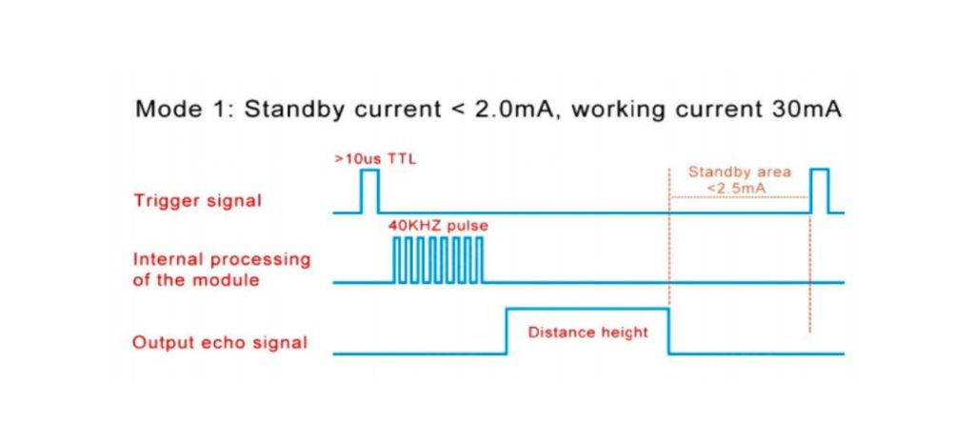Timing Diagram showing the different steps in operating the sensor in Echo Trigger mode. A High signal on trigger pin starts transmission. By measuring the time takes for the sensor to measure the reflected signal, we can calculate the object distance

Sample Code to test Echo Trigger Mode –

#define echoPin 11 // attach pin D2 Arduino to pin Echo of JSN-SR04T

#define trigPin 12 //attach pin D3 Arduino to pin Trig of JSN-SR04T

// defines variables

long duration; // variable for the duration of sound wave travel

int distance; // variable for the distance measurement

void setup() {

pinMode(trigPin, OUTPUT); // Sets the trigPin as an OUTPUT

pinMode(echoPin, INPUT); // Sets the echoPin as an INPUT

Serial.begin(9600); // // Serial Communication is starting with 9600 of baud rate speed

Serial.println("Ultrasonic Sensor HC-SR04 Test"); // print some text in Serial Monitor

Serial.println("with Arduino UNO R3");

}

void loop() {

// Clears the trigPin condition

digitalWrite(trigPin, LOW); //

delayMicroseconds(2);

// Sets the trigPin HIGH (ACTIVE) for 10 microseconds

digitalWrite(trigPin, HIGH);

delayMicroseconds(10);

digitalWrite(trigPin, LOW);

// Reads the echoPin, returns the sound wave travel time in microseconds

duration = pulseIn(echoPin, HIGH);

// Calculating the distance

distance = duration * 0.034 / 2; // Speed of sound wave divided by 2 (go and back)

// Displays the distance on the Serial Monitor

Serial.print("Distance: ");

Serial.print(distance);

Serial.println(" cm");// working code for aj-sr04m

}

Measuring the obstacle distance using Waterproof Ultrasonic Senor module in Traditional mode, output distance obtained at serial monitor and distance of obstacle in mm

This mode is useful if you want to replace a traditional trigger/echo sensor with this module. Numerous libraries are available so programming is easy. But it requires 2 IO Pins and gets complicated as the number of sensors increase.

1. Low Power Traditional Trigger and Echo Mode

This Mode of working is similar to the previous mode, but it offers extreme low power consumption. This mode consumes only around 40uA of current during sleep. Perfect if you are powering the sensor from a battery. To enter this mode replace resistor R19 by 300KΩ resistor onboard.

In this mode, the module is in sleep mode, when a high signal with a pulse width of more than 1ms TTL trigger is supplied, the module starts transmitting and receiving the ultrasonic signal.

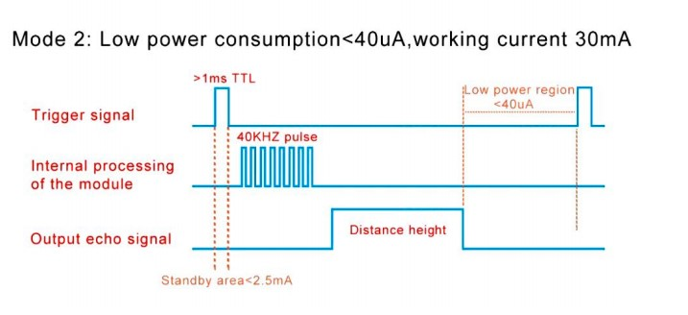Timing Diagram: Module is in Low Power Sleep Mode. A High signal of 1ms on trigger pin starts transmission. By measuring the time takes for the sensor to measure the reflected signal, we can calculate the object distance

The working code for his mode is the same as mode 1. Modify the trigger pulse to a pulse width greater than 1ms to trigger the sensor from sleep mode.

This Mode is very useful if you use the sensor in low-power battery-driven applications. It offers low power consumption, zero interference with other sensors, and is simple to use.

1. Automatic Serial Mode

Use Resistance value 120KΩ, to enter the Automatic Serial port mode. The trigger signal is not used in this mode. In this mode, the distance calculation happen on the sensor and it outputs the distance directly over the Echo line every 120ms.

AJ-SR04m transmits bytes per measurement, which is shown below.

| **Byte1** | **Byte2** | **Byte3** | **Byte4** |
| --- | --- | --- | --- |
| Start Byte | Upper Byte | Lower Byte | Checksum |

Showing 1 to 1 of 1 entries

40KHZ pulse generated internally for every 120ms and gives the output distance in echo line. distance in (mm). The checksum is the output,  and it is the sum of the Upperbyte and LowerByte. Checksum is used to verify the packet loss during transmission.

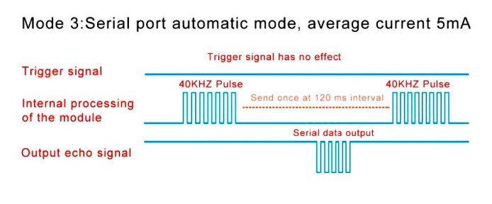Timing Diagram: Module continuously outputs the distance data in the Echo line using Serial protocol

Sample Code to test Automatic Serial Mode –

#include <SoftwareSerial.h>

#define rxPin 10

#define txPin 11

SoftwareSerial jsnSerial(rxPin, txPin);

void setup() {

jsnSerial.begin(9600);

Serial.begin(9600);

}

void loop() {

/*jsnSerial.write(0x01);

delay(10);*/

if(jsnSerial.available()){

getDistance();

//

}

}

void getDistance(){

unsigned int distance;

byte startByte, h_data, l_data, sum = 0;

byte buf[3];

startByte = (byte)jsnSerial.read();

if(startByte ==255){

jsnSerial.readBytes(buf, 3);

h_data = buf[0];

l_data = buf[1];

sum = buf[2];

distance = (h_data<<8) + l_data;

if((( h_data + l_data)) != sum){

Serial.println("Invalid result");

}

else{

Serial.print("Distance [mm]: ");

Serial.println(distance);

}

}

else return;

delay(100);

}

Use this mode if you do not want to do the distance calculations on your host microcontroller.

1. Low Power Serial Mode:

Use 47KΩ at R19 to enter the Low power Serial Mode. In this mode the sensor is in low power sleep mode and consumes 20uA. When the trigger command(0x01) is received on the trigger pin, the sensor wakes up, performs distance calculation and outputs the distance over the echo line. The sensor goes back to sleep after transmitting data. This mode has a low power consumption compared to the previous mode 3.

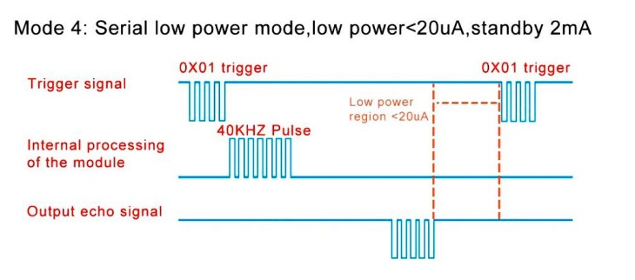Timing Diagram: Module is in sleep. A 0x01 data on trigger pin starts distance calucation. After the calculation, the distance is output on the Echo line. The module goes back to sleep

Sample Code to test Low Power Serial Mode –

#include <SoftwareSerial.h>

#define rxPin 10

#define txPin 11

SoftwareSerial jsnSerial(rxPin, txPin);

void setup() {

jsnSerial.begin(9600);

Serial.begin(9600);

}

void loop() {

jsnSerial.write(0x01);

delay(50);

if(jsnSerial.available()){

getDistance();

}

}

void getDistance(){

unsigned int distance;

byte startByte, h_data, l_data, sum = 0;

byte buf[3];

startByte = (byte)jsnSerial.read();

if(startByte == 255){

jsnSerial.readBytes(buf, 3);

h_data = buf[0];

l_data = buf[1];

sum = buf[2];

distance = (h_data<<8) + l_data;

if((( h_data + l_data)&0xFF) != sum){

Serial.println("Invalid result");

}

else{

Serial.print("Distance [mm]: ");

Serial.println(distance);

}

}

else return;

}

Measuring the obstacle distance using Waterproof Ultrasonic Senor module in Lowe power serial mode, output distance obtained at serial monitor and distance of obstacle in mm

Use this mode if you do not want to do distance calculations on your host and if you want low power applications.

1. Computer Printing Mode:

Simply short the resistor R19(0 Ohm) to enter to this mode. This is the easiest mode compare to other modes – the distance calculation happens onboard and the output data is directly readable on any serial terminal software(including the Serial Monitor on Arduino IDE).

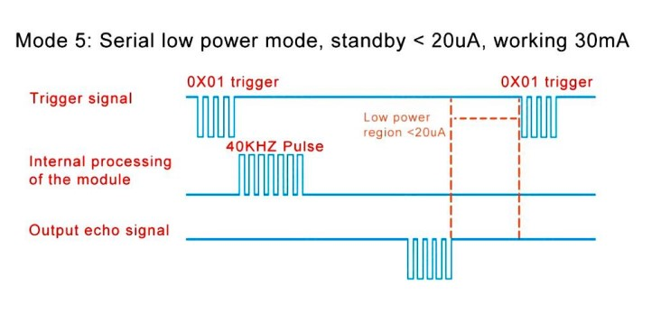

Sample Code to test Computer Printing Mode –

#include <SoftwareSerial.h>

#define rxPin 10

#define txPin 11

SoftwareSerial jsnSerial(rxPin, txPin);

void setup() {

jsnSerial.begin(9600);

Serial.begin(9600);

}

void loop() {

jsnSerial.write(0x01);

delay(10);

if(jsnSerial.available()){

Serial.println(jsnSerial.readString());

}

}

Measuring the obstacle distance using Waterproof Ultrasonic Senor module in Computer printing mode, output distance obtained at serial monitor and distance of obstacle in mm

Use this mode if you want a quick and easy way to read the sensor data. Without any host processing.

You can purchase all products that were used in this article here –

* Ultrasonic sensor,
* Arduino Uno
* Breadboard
* Jumper Cables

Many such modules are available for sale on our website. You can check them out here – [www.probots.co.in](http://www.probots.co.in/)